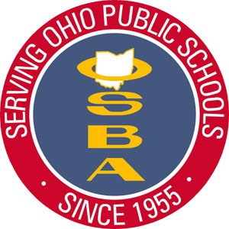

Northwest Region Recognition Programs Programs
Northwest Region Humanitarian Award

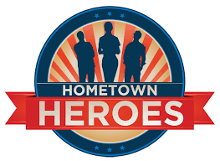 Highlights individuals and groups who actively engage in exceptional altruistic efforts to improve the welfare of others during the pandemic and beyond. The purpose is to recognize those demonstrating the ethics of kindness, benevolence, and sympathy in their schools and communities. These individuals have a sincere concern for those around them and go above and beyond the call of duty.

Who’s Who in the NW Region Excellence Award for Outstanding Leadership
Highlights organizational leadership. This award is special because it recognizes that leadership occurs at ALL levels of the organization and community; from the playground to the central office. This award is reserved for those who demonstrate exceptional leadership for the betterment of the district during the pandemic. The nominees for this award are generated by those who work with an around the honoree.

NW Region Excellence in Community Service Award
Highlights school district, community members, and organizations engaged in activities to support and enhance their school and community during the pandemic. This award honors selfless, donated service or activities that are performed by someone or a group of people for the benefit of the public or its institutions demonstrating a deliberate connection between the community and educational development.

The Northwest Region Spring Conference will be held on Thursday, March 11, 2021 from 7:00 to 8:20 pm via Zoom; a cloud based conferencing service. We will share nomination presentations from each of the categories above. All submissions not shared during the conference will be shared on the Northwest Region OSBA Community Page.
Who are your District & Community Heroes?

Submissions should include a narrative and pictures or a media clip of no more than 90 – seconds sharing your (s)hero. The composition of the clip is of your own choosing! It may be the honoree, or others submitting on their behalf (see details below).
Please include the highlighted information below with all submissions.

Award Category: Excellence in Community Service  Humanitarian Award  Excellence Award for Outstanding Leadership 

Honoree Information:
Honoree Name _____________________________________________ School District_____________________________________________
Honoree E-mail _____________________________________________
School/Grade Level/Title/ Position (if applicable) _____________________________________________
School Address _____________________________________________ School Phone _____________________________________________
Group Advisor /Director (if applicable) _____________________________________________
Advisor E-mail _____________________________________________ Advisor Phone _____________________________________________

Nominator/Submitter Information:
Nominator Name _____________________________________________ E-mail _____________________________________________
Phone _____________________________________________ Position _____________________________________________

Story/narrative: ___________________________________________________________________________________________________________________
_________________________________________________________________________________________________________________________________
_________________________________________________________________________________________________________________________________
_________________________________________________________________________________________________________________________________

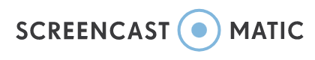
Please submit your nomination by January 31, 2021. If you plan to submit a media clip it must be submitted no later than Friday, February 12, 2021.
Save your clip in any form that includes a link such as Zoom, YouTube, Screencast O Matic, or any program that allows the clip
to be saved to the CLOUD and sent in a link via email to jjacksonmay@ohioschoolboards.org.There is no cost to attend; however, you will need to register from OSBA’s website at http://links.ohioschoolboards.org/.................You may also e-mail your reservation to Melanie Price at OSBA: mprice@ohioschoolboards.org
*Clips not included for the program will be posted on the NW Region OSBA Community Page to share will the all the OSBA member districts.

Please contact NW Regional Manager Judy Jackson May at jjacksonmay@ohioschoolbaords.org or 419.581.9782 or 419.575.0663 with any questions or comments!

