OSBA search consultant team

Cheryl Ryan

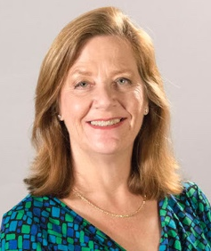
Cheryl Ryan began as a School Board Services Consultant with the OSBA Division of Board Development in September 2007. In June of 2011, she was promoted to Deputy Director of School Board Services and was promoted to Director of Board Services in 2015. She added the responsibility of Management Services in 2017. She has been instrumental in facilitating superintendent and treasurer searches across the state and leads the team of other search professionals at OSBA.

A former school board member, Ryan believes that the board member perspective, combined with her OSBA experience adds great value to the process and to the board members OSBA serves.

Other activities she promotes, and that also support holistic board governance, include customized workshops on goal-setting and evaluation, full strategic planning services, board self-assessment, superintendent and treasurer goal setting and evaluation, community survey services and board leadership team communication and development.

Prior to OSBA, Cheryl served as Director of International Programs at The Ohio State University’s Fisher College of Business, where she directed the activities of the university's Center for International Business Education & Research (CIBER). Before coming to Ohio, she served in a similar capacity at the University of Colorado at Denver.

She has an undergraduate degree in psychology from Colorado State University and an MBA, with an emphasis in organizational strategy and international business, from the University of Colorado.

Teri Morgan
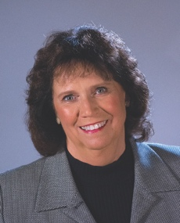
Teri joined the OSBA Board and Management Services division in the fall of 2015. She is the division’s senior deputy director. Professionally, Teri has served as Communications Manager for Delaware County and before that, OhioHealth. She has extensive management and public relations experience with several non-profit associations.

An experienced board of education member, Teri served on the boards of Olentangy Local Schools, the Delaware County Career Center, the Educational Service Center of Delaware-Union Counties and the ESC of Central Ohio.

An experienced trainer and facilitator, Teri’s experience in communications and in board governance serves her well in the Board and Management Services division.

Teri earned a communications degree from Miami University and resides in Powell, Ohio.

Steve Horton

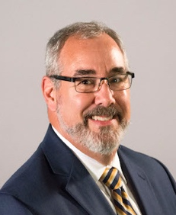
Steve joined OSBA in fall 2013 as a Board Services Consultant in the Board and Management Services Division. In 2018, he was promoted to Senior Board and Management Services Consultant.

Steve brings a strong passion for public education and board work. He began his professional life as a middle school general music and choral music teacher in Wilmington, Ohio. His father was a school district superintendent for 22 years, followed by another 25 years as a consultant with ODE’s Fiscal Oversight Team, and his mother was an art teacher, then third and sixth grade teacher for more than 25 years.

After becoming increasingly more involved in his community’s district, Steve was elected to the Mt. Healthy Board of Education in November of 2011 and served as board president in 2013 until resigning his seat to come to OSBA. The experience of living and serving in a high poverty, urban school district has given Steve an important insight into the needs and disparities that exist among our state’s public schools and the need for strong district leadership. This passion and understanding are part of Steve’s work with OSBA in forming a cohort of urban school district leaders known as the Urban Network.

Prior to OSBA, professionally, for ten years Steve was Director of Education for an audio electronics manufacturer specializing in installed high-end audio distribution systems. He was responsible for the development of all educational materials and training for the company’s international base of installers, distributors and sales representatives. Steve is well known throughout the custom electronics industry as a premier presenter and classroom facilitator. He was also a regular presenter at industry trade shows and other events. In addition to presenting, he used his skills to write manuals, newsletter and publication articles, and develop an extensive online learning center for the company’s products.

Steve is a graduate of Ohio Wesleyan University in Delaware, Ohio with a BA in Music Education.

