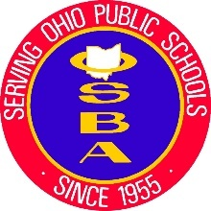
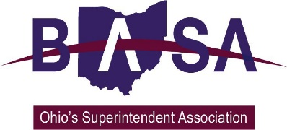

House Primary and Secondary Education Committee
HB 165 Proponent Testimony
Ohio Association Secondary School Administrators
Ohio Association of Elementary School Administrators
Ohio School Boards Association
Buckeye Association of School Administrators
June 4, 2019

Good afternoon, Chair Blessing, Vice Chair Jones, Ranking Member Robinson, and members of the House Primary and Secondary Education Committee. Thank you for the opportunity to speak to you today regarding our support for House Bill 165. My name is Thomas Ash, and I am the Director of Governmental Relations for the Buckeye Association of School Administrators (BASA). Joining me today for this testimony and in answering your questions are Jay Smith, Deputy Director of Legislative Services for the Ohio School Boards Association, and Barbara Shaner, advocacy specialist for the Ohio Association of Secondary School Administrators (OASSA) and the Ohio Association of Elementary School Administrators (OAESA).

We are here today as proponents for HB 165, which would require the State Board of Education to adopt either the most recent standards developed by the American Association for Health Education or health education standards prescribed by the State Board itself.

As was noted during sponsor testimony, Ohio is currently the only state with no health education standards.

It is important to note that, while the State Board would be required to disseminate those standards to school districts, no local board of education would be required to adopt those standards.

Since the standards were most recently revised, the American Association for Health Education has merged with other national and district organizations to become the Society of Health and Physical Educators (or SHAPE America).

We would also note the standards provide a framework for curriculum development and do not specify curriculum or content.

The standards are intended to create a framework for students to make healthy choices. Ultimately, the goal is for students to practice health-enhancing behaviors and avoid health risks.

Interestingly, the standards would provide a framework for instruction on many topics in which the General Assembly has expressed interest or is requiring, such as dating violence, bullying and harassment, substance abuse prevention, and positive youth development.

We know that this General Assembly and administration are well aware of the substance abuse crisis throughout Ohio. Health education standards would help to embed this issue as part of normal instruction throughout the schoolyear.

In addition, the Ohio Department of Health in 2016-2017 conducted a randomized body mass index (BMI) screening of preschool children from three to five years of age. The results from the 3,098 screened children showed that almost 26% of these children were either overweight or obese. It is important that we teach positive health attitudes to our children in a way that is developmentally appropriate.

Chair Blessing, thank you for this opportunity to express our support for House Bill 165, and we will be happy to address any questions at the pleasure of the chair.

