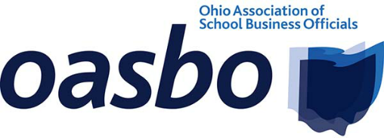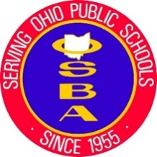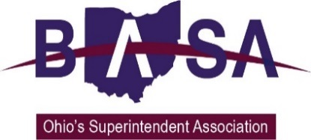

Senate Transportation, Commerce, and Workforce Committee
Sub. Senate Bill 134 Proponent Testimony
Ohio School Boards Association
Buckeye Association of School Administrators
Ohio Association of School Business Officials
Oct. 2, 2019

Chairman McColley, Ranking Member Antonio, and members of the Senate Transportation, Commerce, and Workforce Committee. Thank you for the opportunity to speak to you today in support of Sub. Senate Bill (SB) 134, the School Bus Safety Act. My name is Jay Smith with the Ohio School Boards Association (OSBA). Joining me for this testimony is Barbara Shaner with the Ohio Association of School Business Officials. Kevin Miller with the Buckeye Association of School Administrators also joins us in support of Sub. SB 134 but was not able to be here today.

Our organizations represent public school district boards of education, superintendents, treasurers/CFOs, business managers, and other school business officials from around the state. Our members appreciate Senator Gavarone introducing this legislation that will have a positive impact on student safety in and around school buses.

The number of vehicles illegally passing stopped school buses is a growing concern for all districts. OSBA organized a bus passing survey for districts to record and report their incidents for one day this past March. The results from the 183 districts that returned the survey were staggering. Nearly one third of the 15,000 school bus drivers completed the survey and recorded over 1,500 buses were illegally passed. If all drivers experience this rate of being illegally passed – Ohio could have 4,500 buses illegally passed each day. The following factors were revealed from the survey:
- 45% of the illegal passing occurred in the morning
- 52% were illegally passed in the afternoon
- 73% were passed as approaching the bus from the front
- 27% were passed from the rear
- 98% were passed on the left
- 2% were passed on the right

In addition to increasing penalties for these motorists who are jeopardizing student safety, the bill clarifies that cameras may be installed on school buses in order to capture an image and or video of a person improperly passing a school bus. The bill also states that these images or video can be used as evidence in any criminal case. School bus drivers are committed to keeping their students safe and thus are consumed with monitoring where their students are as well as traffic in and around the bus. The use of camera evidence greatly helps the driver in reporting incidents in hopes that enforcement action may be taken by police and prosecutors.

We are also appreciative of the proposed appropriation to assist school districts in purchasing and equipping their busses with this camera technology.

Additionally, by designating August as “School Bus Safety Awareness Month”, we are hopeful that with the help of the media and our local communities, we can create more awareness of the laws designed to enhance student safety around our school buses.

Chairman McColley and members of the Senate Transportation, Commerce, and Workforce Committee, thank you for your time and attention. We urge your support for Sub. SB 134 and would be happy to address your questions.

