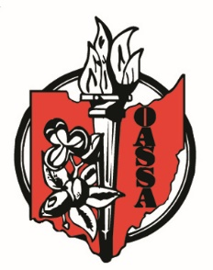

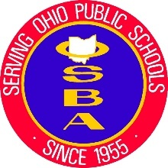
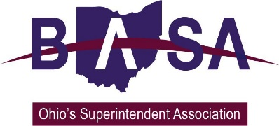

Senate Education Committee
SB 121 Proponent Testimony
Ohio Association Secondary School Administrators
Ohio Association of Elementary School Administrators
Ohio School Boards Association
Buckeye Association of School Administrators
October 1, 2019

Good morning, Chair Lehner, Ranking Member Fedor, and members of the Senate Education Committee. Thank you for the opportunity to speak to you today regarding our support for Senate Bill 121. My name is Barbara Shaner, advocacy specialist for the Ohio Association of Secondary School Administrators (OASSA) and the Ohio Association of Elementary School Administrators (OAESA). Joining me for this testimony and in answering your questions is Jay Smith representing the Ohio School Boards Association (OSBA) Kevin Miller from the Buckeye Association of School Administrators (BASA) was unable to be here in person but asked that we speak on his behalf.
We are here today as proponents for SB 121 which would require the State Board of Education to adopt Health Education Standard for grades kindergarten through twelve. The Board must use the same methodology to establish the standards that it uses for the state’s other academic content standards.
It is important to note that, while the State Board would be required to disseminate those standards to school districts, no local board of education would be required to adopt those standards. We would also note the standards provide a framework for curriculum development and do not specify curriculum or content.

The standards are intended to create a framework for students to make healthy choices. Ultimately, the goal is for students to practice health-enhancing behaviors and avoid health risks.

Interestingly, the standards could provide a framework for instruction on many topics in which the General Assembly has expressed interest or is currently requiring, such as dating violence, bullying and harassment, substance abuse prevention, and positive youth development.

We know that this General Assembly and administration are well aware of the substance abuse crisis throughout Ohio. Health education standards would help to embed this issue as part of normal instruction throughout the schoolyear.

In addition, the Ohio Department of Health in 2016-2017 conducted a randomized body mass index (BMI) screening of preschool children from three to five years of age. The results from the 3,098 screened children showed that almost 26% of these children were either overweight or obese. It is important that we teach positive health attitudes to our children in a way that is developmentally appropriate.

Ohio is the only state in the union that does not have state standards for Health Education. We think it is important that we change that with the passage of SB 121.

Chair Lehner, thank you for this opportunity to express our support for Senate Bill 121, and we will be happy to address your questions.

