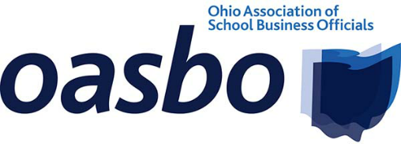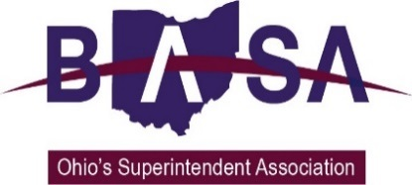

House Primary and Secondary Education Committee
House Bill 43 Proponent Testimony
Ohio School Boards Association
Buckeye Association of School Administrators
Ohio Association of School Business Officials
June 11, 2019

Chairman Blessing, Vice Chairman Jones, Ranking Member Robinson, and members of the Committee. My name is Jay Smith, Deputy Director of Legislative Services for the Ohio School Boards Association. Joining me today for this testimony are Barbara Shaner, Advocacy Specialist for the Ohio Association of School Business Officials (OASBO) and Thomas Ash, Director of Governmental Relations for the Buckeye Association of School Administrators. Thank you for the opportunity to speak to you in support of House Bill (HB) 43.

Collectively, we represent public school board members, superintendents, treasurers/CFOs, and other school business officials from around the state. Today we are here representing their interests. We believe HB 43 would restore the ability for local boards to make decisions that best meet the needs of the school district and the surrounding community when it comes to property disposal.
School facilities represent a major investment of community resources for public education. School facilities and real property represent the most visible evidence of that investment. School board members are stewards of these community resources. Good stewardship requires that facilities be properly maintained and that any proposed disposal of property be of direct benefit to the district and its community. The locally elected board of education must retain the final decision in these matters.
HB 43 provides school districts with the flexibility to sell or lease real property in a manner that offers the most benefit to the school district as determined by the locally elected board of education. It repeals the “right of first refusal” by charter/community schools and a specific list of other education-related entities, to purchase property not currently used by a school district. The bill allows local school boards the flexibility to make facility sales and purchasing decisions based on the needs of the district and the community.

Our organizations have long opposed provisions in current law that mandate the actions of a board of education when it comes to the disposal of property. Such decisions should be made by those individuals elected by the community and based on local factors. Ohio’s law which requires districts to comply with a forced “right of first refusal” for certain entities may not be in the best interest of the district or the surrounding community.

Mr. Chairman, this concludes our testimony. We urge you to support HB 43. We will be happy to address your questions.

