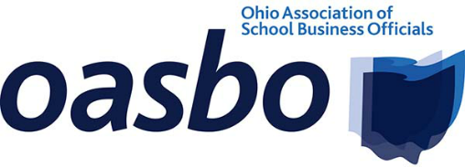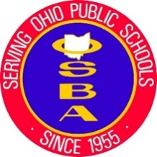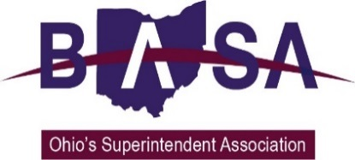

House Finance Subcommittee on Primary and Secondary Education
House Bill 33
Ohio School Boards Association
Buckeye Association of School Administrators
Ohio Association of School Business Officials
March 22, 2023

Chair Richardson, Ranking Member Isaacson and members of the House Finance Subcommittee on Primary and Secondary Education. Thank you for the opportunity to present testimony today on House Bill (HB) 33, the biennial budget. I’m Jennifer Hogue with the Ohio School Boards Association. Joining me for this testimony and in answering your questions are Paul Imhoff with the Buckeye Association of School Administrators and Katie Johnson with the Ohio Association of School Business Officials. Our organizations represent public school districts, career technical education centers and educational service center boards of education, superintendents, treasurers/CFOs, business managers and other school business officials from around the state.

Fair School Funding Plan
We continue to support the Fair School Funding Plan because it provides a fair, predictable and reliable means of meeting the needs of students. We appreciate that Governor DeWine chose to include the next two years of the phase-in as a part of his budget proposal. Ohio is in a healthy financial position having ended FY 22 $2.7 billion above estimates, being $1.2 billion over estimates so far in FY 23, and holding another $3.5 billion in Ohio’s rainy day fund. We believe that with this firm financial footing, the time is right to invest in Ohio’s public school students by updating and fully funding the Fair School Funding plan in the upcoming biennium.

We request that HB 33 be amended to use FY 22 data for inputs to the formula, and the formula be fully phased in during this budget. Additionally, we request that you add a provision to ensure that updates to the capacity measures in future years will trigger updates for the inputs data.

Economically Disadvantaged Student Cost Study
After the last biennial budget, Ohio undertook a number of studies to look at the unique educational needs of certain categories of students including students with disabilities, gifted students and English learners. However, Ohio has yet to conduct a study on the needs of economically disadvantaged students, which account for nearly 50% of Ohio’s students. We request that the budget be amended to require and fund an independent comprehensive analysis of the true costs of providing supplemental services to economically disadvantaged students in Ohio.

Career Technical Education
Ohio is blessed to have amazing career technical education opportunities that provide students a pathway for lifelong success. Many of these programs are experiencing waitlists because they do not have the capacity necessary to serve all the students interested in enrolling in their programs. We are thankful that Governor DeWine’s budget proposal recognizes the importance of career technical education and provides funding through several initiatives including the career technical education equipment grants. This program will provide $100 million over the biennium for schools to make the equipment purchases that will allow them to expand their programs to serve additional students. We request that the House maintain the programs for career technical education proposed by Governor DeWine.

Early Literacy
We also appreciate Governor DeWine’s proposed investments in literacy and the comprehensive approach his proposal takes by providing funding for all aspects of implementation from professional development to curriculum and instructional materials to literacy coaches. Each aspect of implementing literacy instruction based on the science of reading has been thoughtfully addressed and funding provided. We ask that the budget be amended to allow districts who were early adopters of the science of reading to be eligible for reimbursement for funds they previously invested for this purpose. We also re quest that the budget be amended to require institutions of higher education to instruct pre-service teachers in the science of reading.

English Learners
The budget removes the exemptions from state assessments and report cards for English learners who have been enrolled in school in the United States for less than a full school year. The state assessments do not benefit the instruction of new English learners and would take away valuable time that should be used for instruction. English learners will continue to be evaluated locally through diagnostic assessments. These diagnostic assessments serve to evaluate student needs, identify their strengths, and inform instruction. Testing English learners with state assessments before they have a chance to complete a full year of instruction in the United States will not have any added benefit for the student. We ask that the bill be amended to restore these exemptions for English learners who have not attended a full school year in the U.S.

Voucher Expansion
Our organizations continue to have concerns about expanding Ohio’s voucher programs. We believe that Ohio should first invest in the students who have chosen Ohio’s public schools. These students continue to wait for the state to fully fund their success through the Fair School Funding Formula. In addition, we believe that additional expansion of vouchers should come with additional academic and financial accountability. Private schools enrolling students on state vouchers should be held to the same assessments, report cards, financial reporting and audits as public schools. Providing the same measures and reporting will provide parents with transparent and consistent information across school settings while ensuring that taxpayer funds are being used in appropriate ways to provide a quality education.

School Resource Officers
We thank Governor DeWine for his continued commitment to school safety. This budget provides an additional $194.1 million in each fiscal year for schools that choose to employ a school resource officer (SRO). ODE has expressed it is their intent to provide a base amount of $94,500 per building to reflect the salary and benefits cost of the SRO. ODE also shared that they intend to apply the state share calculation to this amount for public school applicants. Other educational settings, such as private and charter schools, would instead receive the full amount from the state. We ask that the bill be amended to add parity across educational settings by explicitly stating that all buildings will receive full state funding for the cost of SROs.

Transportation
Pupil transportation presents a significant challenge for many districts. From the challenges of finding drivers to rising fuels costs, districts find themselves needing to pivot and be creative as they work to ensure safe delivery of students to and from school each day. As a result of the current environment, some districts have been forced to make choices that have resulted in the district being found to be out of compliance by ODE resulting in the withholding of funds withheld from the district. Often times these issues are caused by lack of funding and withholding funding only serves to exacerbate the problem that resulted in the finding of noncompliance. We request that the budget bill be amended to remove financial penalties for noncompliance with pupil transportation laws.

As it relates to funding of the minimum state share for transportation, we appreciate Governor DeWine increasing the minimum state share from 33.33% in FY23 to 37.5% in FY24 and again to 41.67% in FY25. These increases reflect the suggestions of the Fair School Funding Plan Workgroup. However, funding for the school bus purchase program provided under the previous budget was not continued in this proposal. We ask that funding for the school bus purchase program be continued for FY 24 and FY 25 under the same guidelines established by the Ohio Department of Education. This funding provides grants of at least $45,000 per bus for districts to remove the oldest model year and highest mileage school buses used for regular route service in Ohio.

Free Application for Federal Student Aid
The bill also includes a requirement that students complete the FAFSA as a requirement for graduation. The bill would allow parents to opt out of completing the forms and for districts to provide a record of circumstances that make it impossible or impractical for the student to complete the requirement. The FAFSA is a cumbersome document and there is merit in having students complete the FAFSA to see what types of aid would be available to them making post-secondary education a reality. However, this need not be a graduation requirement. We request that, instead, districts be encouraged to provide parent outreach and partner with their community to help parents navigate and complete the FAFSA.

Chair Richardson and members of the subcommittee, thank you for your time and attention. We would be happy to answer any questions you may have at this time.

