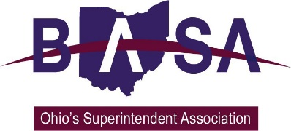

House Primary and Secondary Education Committee
HB 239 Proponent Testimony
Ohio Association Secondary School Administrators
Ohio Association of Elementary School Administrators
Ohio School Boards Association
Buckeye Association of School Administrators
June 4, 2019

Chair Blessing, Vice Chair Jones, Ranking Member Robinson, and members of the House Primary and Secondary Education Committee. Thank you for the opportunity to speak to you today in support of HB 239. I am Barbara Shaner, advocacy specialist for the Ohio Association of Secondary School Administrators (OASSA) and the Ohio Association of Elementary School Administrators (OAESA). Joining me today for this testimony and in answering your questions are Will Schwartz, representing the Ohio School Boards Association (OSBA), and Thomas Ash with the Buckeye Association of School Administrators (BASA).

Our organizations represent public school district boards of education, superintendents and elementary and secondary school principals, and other school administrators from around the state. Our members have a deep interest in the number of assessments students take. HB 239 reduces the number of required state assessments to just those required to meet federal minimums. We support this change.

HB 239 also creates work groups at the district level to examine the amount of time students spend on district-required testing and to make recommendations to the district board of education on how to reduce testing amounts. The work group will be representative of the stakeholders in the best interest of students. The group would be required to make recommendations to the board of education within six months of forming.

Current law requires that if boards of education wish to exceed the state maximum amount of time students spend on assessments, the board must pass a resolution. The bill requires that boards first to take into account the recommendations of the new work group. It also requires the board to adopt a resolution annually if it will exceed the state limitations. We think the “annual resolution” requirement is excessive, particularly if the board is acting on the recommendations of the local work group. We suggest the board not be required to adopt a new resolution unless there is a change in the district’s practices related to testing times from the previous year.

In conclusion, HB 239 scales back the number of state-required tests students must take. This change has long been the hope of the members of our organizations. We believe the changes in the bill will help to remove the high-stakes nature of tests.

Chair Blessing, thank you for this opportunity to offer our support for reducing required testing to the required federal minimums, and we would be happy to address your questions at the pleasure of the chair.

