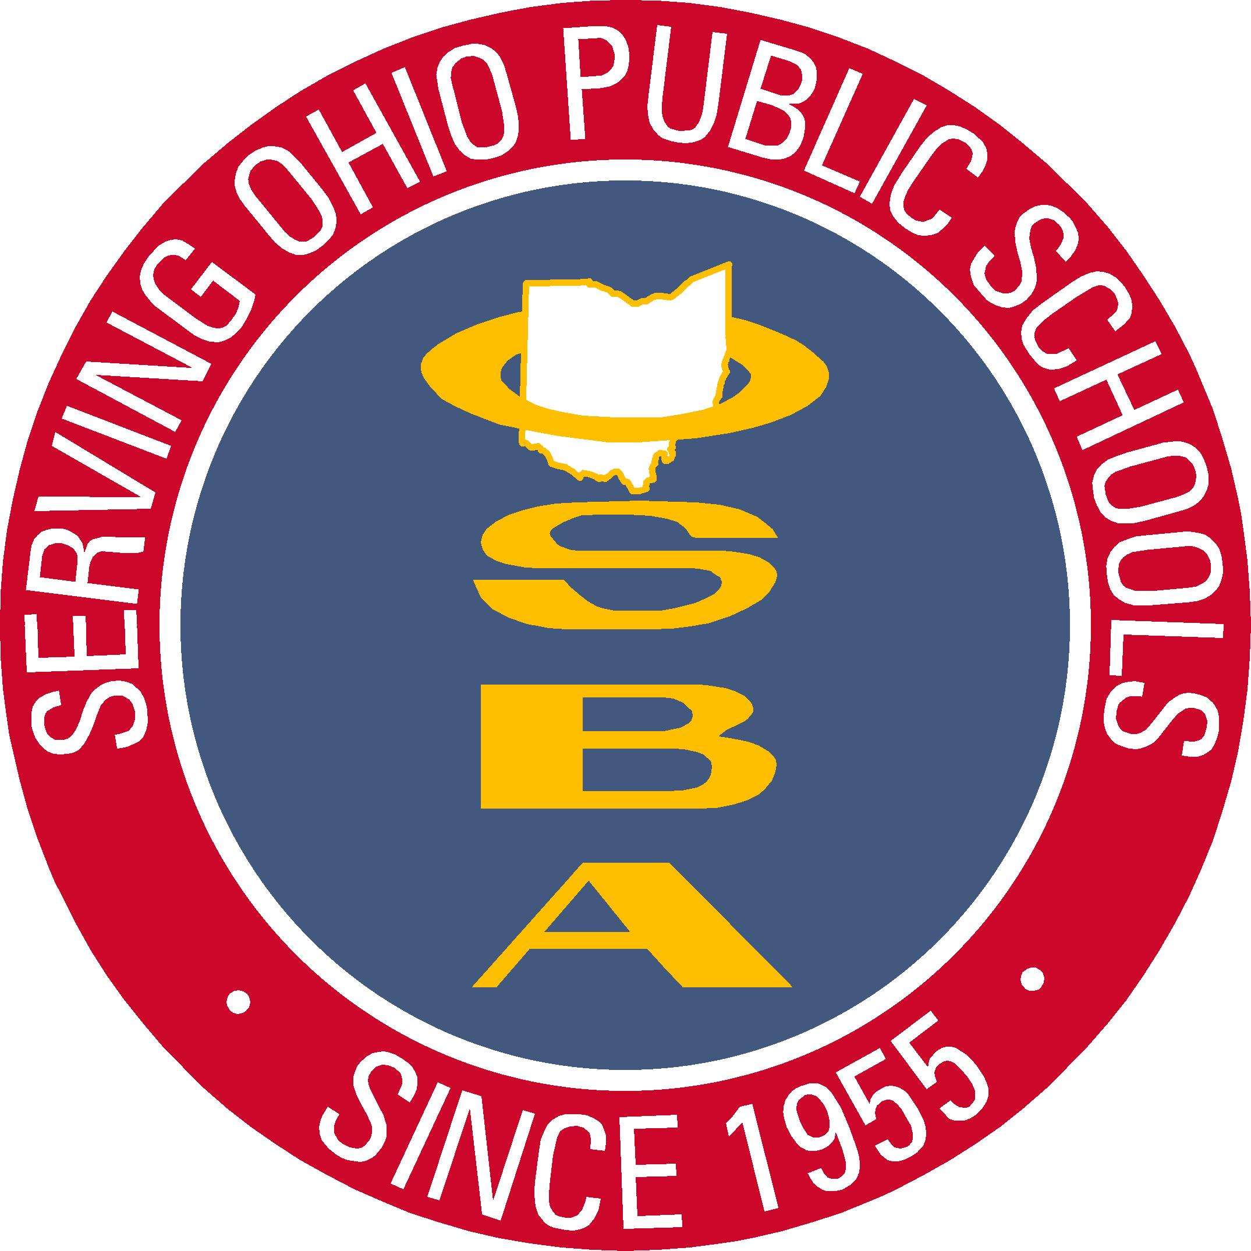
Ohio School Boards Association
Southwest Region Recognition Program
2021 Nomination Form

_____ Outstanding administrator – Students
_____ Outstanding administrator -- Operations
_____ Outstanding classified staff member – Students
_____ Outstanding classified staff member -- Facilities
_____ Outstanding faculty member
_____ Outstanding treasurer
_____ Outstanding superintendent
_____ Outstanding community/public relations person
_____ Outstanding board member from a neighboring school district – “Warren Stevens Award”*
_____ Outstanding Community Business Leader
_____ Outstanding Career Center Board Member – “Spahr/Steele Award”

I would like to nominate __________________________________________________________________ from our school to be recognized as being outstanding in one of the above categories. Use a separate nomination form for each different category. (* Note: this category is a board member from a neighboring district as your district’s outstanding board member is recognized in the fall through a different recognition program.) Selection and recognition of outstanding individuals will take place at the Southwest Region Spring Conference on Tuesday, March 9, 2021
Describe the nominee/nomination: (include outstanding qualities, relationships to school and other background information. Please limit endorsements letters to three.)
_______________________________________________________________________________________
_______________________________________________________________________________________
_______________________________________________________________________________________
_______________________________________________________________________________________
_______________________________________________________________________________________
Attach extra sheet, if necessary
Copy this form to make additional nominations
Name of Nominator: ___________________________ Signature of Nominator: _________________________
School: ___________________________________ School District: ________________________________
Telephone: _________________________________ County: _____________________________________
Email: _________________________________
Please return this form by February 5, 2021 to:

Mark Ewing, Regional Manager
Ohio School Boards Association
E-mail: mewing@ohioschoolboards.org

