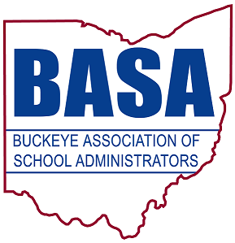

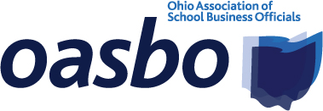
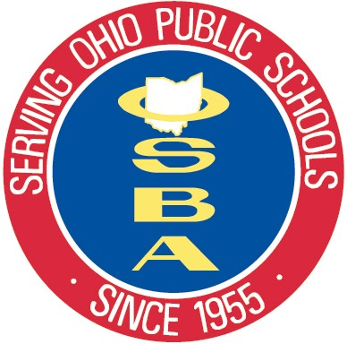

FOR IMMEDIATE RELEASE

Aug. 22, 2013

for more information, contact:

Damon Asbury Barbara Shaner

OSBA director of legislative services OASBO associate executive director

(614) 832-6663 cell (614) 325-9562 cell

dasbury@ohioschoolboards.org barbara@oasbo-ohio.org

Tom Ash

BASA director of governmental relations

(614) 425-3974 cell

ash@basa-ohio.org

New state report card confirms link between income, student performance

COLUMBUS — The new report cards for schools and school districts were made available today to communities throughout Ohio. Analysis of today’s report card release confirms research that shows income and poverty have a direct correlation to student performance.

Among the 135 school districts above the state average income of $51,626, 91% scored an A in the letter grade of standards met category, while just 41% of the 474 districts below the state average income received an A.

Among the 360 districts with student poverty levels less than the state average, 74% earned an A, while only 20% of the 249 districts with poverty levels higher than the state average received an A.

A chart showing the percentage of districts with an A in the letter grade of standards met category, based on income, is attached to the email accompanying this release.

Unlike prior years, the revamped report cards assign A-though-F letter grades to schools in nine different categories, which range from graduation rates to achievement gaps to student performance on state tests.

Instead of ratings such as “excellent with distinction” and “continuous improvement,” schools and school districts ultimately will receive overall letter grades. They will not receive overall letter grades until 2015; the Ohio Department of Education (ODE) is still developing how the scores will be calculated.

—more—

New report card confirms link between income, student performance 2/2/2/2/2

ODE has made the new report cards available to the public on its website at http://reportcard.education.ohio.gov.

For more information, contact the Ohio School Boards Association (OSBA), Buckeye Association of School Administrators (BASA) and Ohio Association of School Business Officials (OASBO). Media contacts are listed at the top of this release.

———

OSBA leads the way to educational excellence by serving Ohio’s public school board members and the diverse districts they represent through superior service, unwavering advocacy and creative solutions.

BASA is a nonprofit professional organization of school system leaders, specifically, superintendents, central office administrators, building-level administrators, higher education administrators and faculty, graduate students and other educational personnel.

OASBO is a not-for-profit educational management organization dedicated to learning, using and sharing the best methods and technology of school business administration.

— 30 —

