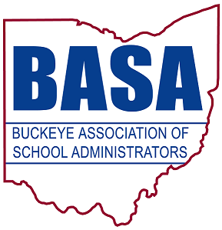

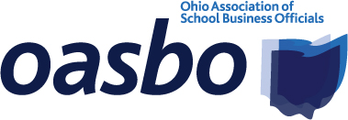


FOR IMMEDIATE RELEASE

June 23, 2014

for more information, contact:

Damon Asbury Barbara Shaner

OSBA director of legislative services OASBO associate executive director

(614) 832-6663 cell (614) 325-9562 cell

dasbury@ohioschoolboards.org barbara@oasbo-ohio.org

Tom Ash

BASA director of governmental relations

(614) 425-3974 cell

ash@basa-ohio.org

ETPI report: State tax policy changes have increased homeowners’ and farmers’ tax burden

COLUMBUS — Ohio homeowners and farmers are shouldering increased tax burdens as a result of major state tax policy changes. That’s the finding of a study released today by the Ohio School Boards Association (OSBA), Buckeye Association of School Administrators (BASA) and Ohio Association of School Business Officials (OASBO).

The study, commissioned by the Education Tax Policy Institute (ETPI) and conducted by school-funding expert Dr. Howard Fleeter, analyzes local property tax trends over the past 36 years. It clearly shows that homeowners and farmers have picked up an added tax burden as a result of major changes in state tax policy. The report is posted on the ETPI website, http://www.etpi-ohio.org.

“It’s no surprise that a shift to other taxpayers has occurred, particularly with the elimination of the tangible personal property tax for businesses a few years ago,” said OSBA Director of Legislative Services Damon Asbury. “What surprised us was just how big the burden has become for homeowners and farmers as compared to business taxpayers.”

The ETPI report shows that while a shift in the overall property tax burden to agricultural and residential property from business property occurred over the entire period of the study —1975 to 2011 — the most significant change occurred between 1991 and 2011, which encompasses the years since the filing of the DeRolph school-funding lawsuit.

“Changes in state policy have had a trickle-down effect on the local taxpayer,” said Tom Ash, BASA director of governmental relations. “The elimination and reduction of business property taxes have not included corresponding long-term replacement revenue for schools. This shift from businesses to homeowners will continue to make it much more difficult for school districts to pass levies when they need to.”
—more—

State tax policy changes have increased homeowners’ and farmers’ tax burden 2/2/2/2/2

While the report does show that property values for homes and agricultural properties have increased over the period, Fleeter indicates those increases are not the cause for the shift. That’s because of what is known as the House Bill (HB) 920 effect, which stabilizes property values in relation to tax levies. Fleeter cites the reduction and elimination of business taxes as the root cause of the shift.

“Ironically, the HB 920 change cited in the report was a move to protect homeowners against inflationary growth in property taxes in the mid-’70s,” said OASBO Associate Executive Director Barbara Shaner. “Yet the many legislative efforts to offer tax relief for businesses since that time have resulted in homeowners making up the difference through both higher rates and a higher share of the tax burden.”

The organizations said they hoped to use the data from the ETPI report in their continued advocacy for a strong and equitable school-funding system — a system that will provide all children, no matter where they live, a high-quality education.

For more information, contact OSBA, BASA or OASBO. Media contacts are listed at the top of this release.

———

OSBA leads the way to educational excellence by serving Ohio’s public school board members and the diverse districts they represent through superior service, unwavering advocacy and creative solutions.

BASA is a nonprofit professional organization of school system leaders, specifically, superintendents, central office administrators, building-level administrators, higher education administrators and faculty, graduate students and other educational personnel.

OASBO is a not-for-profit educational management organization dedicated to learning, using and sharing the best methods and technology of school business administration.

— 30 —

