  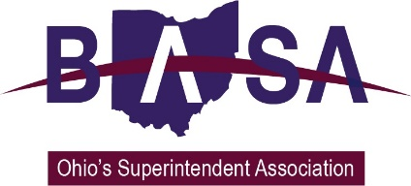

**Written Testimony**

**Senate Finance Committee**

**Amended Substitute House Bill 49 Testimony – Specific Issues**

**Ohio School Boards Association**

**Buckeye Association of School Administrators**

**Ohio Association of School Business Officials**

**May 31, 2017**

Chairman Oelslager, Vice Chair Manning, Ranking Minority Member Skindell, and members of the Senate Finance Committee. Thank you for the opportunity to express our views regarding two specific provisions contained in Am. Sub. HB 49.

Our organizations represent public school district boards of education, superintendents, treasurers/CFOs, business managers and other school business officials from around the state. Our members of course have a keen interest in the provisions proposed in Am. Sub. HB 49.

Am. Sub. HB 49 as passed by the House contains a provision that **would require a school district to pay court costs and legal fees** if it challenges the valuation of a property within its borders as being set too low, and does not prevail. We oppose this change.

The tax commissioner sets tax rates based on the county auditor’s certified valuations of real property, which both the property owner and taxing authority (school board and others) may challenge. This process generates a taxing district’s annual tax revenue. The new budget language will discourage taxing authorities from filing property valuation appeals due to the risk of paying expensive attorney fees and court costs.

These valuation appeals have been a critical part of Ohio’s local tax structure for decades. Its just one component of an appropriate system of “checks and balances” that not only protects local governments and schools, but also the other taxpayers in the taxing district. When schools and local governments challenge the values of a property, the other property taxpayers stand to benefit through lower, more accurate tax rates. It's a way to be sure everyone is paying their fair share.

Under Ohio’s local tax structure, property owners have the ability to challenge what they believe to be a higher than fair valuation of their property. As you heard in testimony last week, the number of claims submitted by property owners far outweigh those of schools and local governments.

Also, School districts do not typically challenge the values on residential property, but the challenges they submit on commercial property can actually serve to protect residential taxpayers. For example, if a commercial property is valued significantly lower than the amount paid for the property in a recent sale, the school district may challenge the property’s taxable valuation to the County Board of Revision. The commercial property owner can defend the lower value or “settle” with the district for a compromise valuation amount. If the school district prevails in the challenge or there is a settlement that sets the valuation higher than before, the residential taxpayers in the district win. Particularly if the school district has passed an Emergency Levy or Bond Issue that requires a set amount of money to be collected. The commercial property owner whose values have increased as a result of the school district challenge will subsequently pay their fair share of taxes, and the other taxpayers will pay less; they won’t have to make up the difference for the commercial property.

The proposal in Am. Sub. HB. 49 that requires school districts and local governments to pay court costs and fees when they do not prevail in a valuation challenge inappropriately upsets the current system of checks and balances. It will have a chilling effect on challenges by schools and local governments, and the benefits these challenges have for Bob and Betty Buckeye.

**We urge you to remove this proposal from Am. Sub. HB 49.**

**CAUV Changes**

We have opposed changes to the Current Agricultural Use Valuation (CAUV) program that would reduce property values for agriculture property. The CAUV provision in Am. Sub. HB 49 would significantly reduce local valuations for agricultural property over time. The timing of the changes in CAUV may mean a lag in the re-computation of districts’ State Share Index to account for the lower values. In other words, districts could appear to the state’s school funding formula to have more property wealth (tax revenue) than they actually have (phantom revenue).

Further, the expansion of benefits to agriculture landowners will create a shift in tax burden from agricultural to residential property owners. The magnitude of this shift will vary by district depending on the percentage of the total property valuation that is made up of CAUV property. Analysis by Dr. Howard Fleeter, consultant for the Ohio Education Policy Institute (OEPI), based on the CAUV provision in Am. Sub. HB 49 and information provided by the Ohio Department of Taxation:

* CAUV property is estimated to make up more than 50% of total valuation in 19 school districts
  + Residential taxpayers in these districts will see the most significant tax increases
* Statewide, CAUV values are estimated to be reduced by 30%
* CAUV property values are estimated to go down by more than 10% per pupil in more than 55 school districts

This comes at a time when residential taxpayers have already experienced a major shift in responsibility for local property taxes. According to data provided by the Ohio Department of Taxation and compiled by Dr. Fleeter Ohio’s many tax policy changes over the years have already resulted in a major shift in burden to residential taxpayers. Since 1990, the burden for residential taxpayers has increased by 50%. In other words, of the total local property tax burden, residential taxpayers are now paying a significantly higher portion than business and agriculture taxpayers.

According to Dr. Fleeter, statewide:

* In 1990 Residential taxpayers paid 44.2% of total property taxes
* In 2015 Residential taxpayers paid 63.8% of total property taxes

Additionally, on average, statewide values for agricultural property currently participating in the CAUV program (Tax Year (TY) 2016) are set at approximately 54% of market value. This allows farmers engaging in agriculture activity to benefit significantly from lower property taxes, a notably lower rate than their residential property owner counterparts. Am. Sub. HB 49 would further expand this already generous benefit.

Rather than making adjustments to the current formula proposed by the industry, we have advocated for an independent study that would serve to modernize the program. **We urge you to remove this proposal and replace it with an independent review of the CAUV program.**

Respectfully submitted,

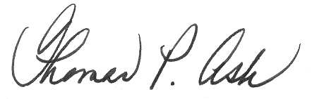

Thomas P. Ash

BASA Director of Governmental Relations

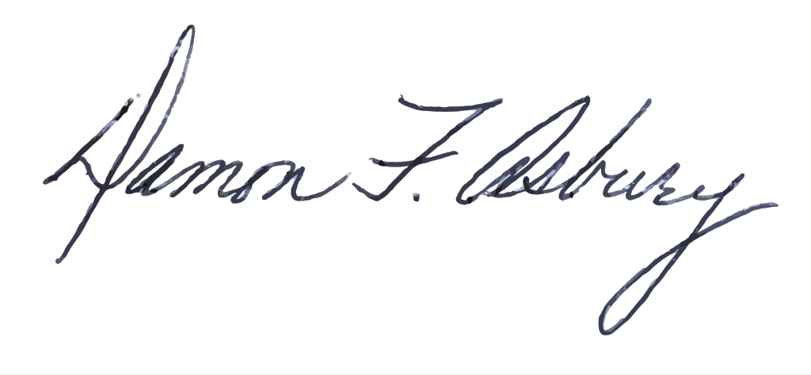

Damon Asbury

OSBA Director of Legislative Services

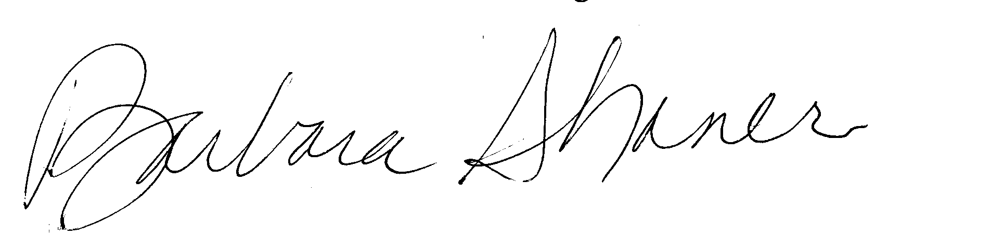

Barbara Shaner

Advocacy Specialist for OASBO