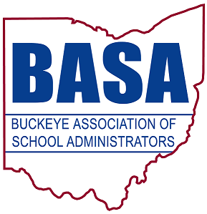

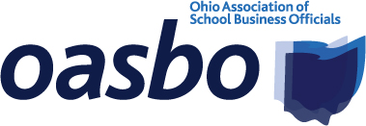
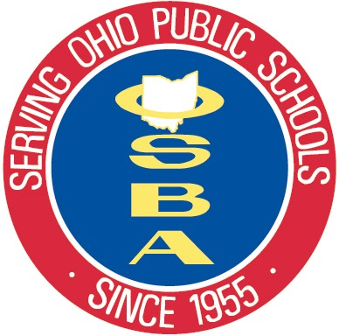

FOR IMMEDIATE RELEASE
Aug. 20, 2014
for more information, contact:

Tom Ash Barbara Shaner
BASA director of governmental relations OASBO associate executive director
(614) 425-3974 cell (614) 325-9562 cell
ash@basa-ohio.org barbara@oasbo-ohio.org

Damon Asbury
OSBA director of legislative services
(614) 832-6663 cell
dasbury@ohioschoolboards.org

Veteran Ohio education policy experts provide in-depth analysis in House testimony supporting Common Core State Standards

COLUMBUS — Two highly respected education policy experts testified in the Ohio House of Representatives today on the importance of maintaining the Common Core State Standards.

Paolo DeMaria and Susan Bodary of Education First spoke before the House Rules and Reference Committee, which is hearing testimony on House Bill 597, legislation that would eliminate the Common Core standards. Education First is a firm specializing in education policy development and strategic implementation.

DeMaria and Bodary, speaking on behalf of the Ohio Business Roundtable, presented a fact-based analysis of the Common Core State Standards that dispelled a number of myths surrounding the standards. Their points included: there is no federal involvement in the Common Core; the standards are not curriculum; they are limited to mathematics and English language arts; and schools are free to teach at levels higher than the standards.

They also stressed how the standards will support improved student achievement and promote a strong and secure economic future for Ohio. In addition, they pointed out how many of the concerns fueling calls for repealing the Common Core already have been addressed in previous legislation.

A copy of DeMaria and Bodary’s testimony and analysis is attached to the email accompanying this release. A copy also is available at: http://www.ohioschoolboards.org/sites/default/files/DeMariaBodaryIntPartyTestimony.pdf

—more—

Veteran Ohio education policy experts provide in-depth analysis 2/2/2/2/2

In its 59th year, OSBA leads the way to educational excellence by serving Ohio’s public school board members and the diverse districts they represent through superior service, unwavering advocacy and creative solutions.

BASA is a nonprofit professional organization of school system leaders, specifically, superintendents, central office administrators, building-level administrators, higher education administrators and faculty, graduate students and other educational personnel.

OASBO is a not-for-profit educational management organization dedicated to learning, using and sharing the best methods and technology of school business administration.

-30-

