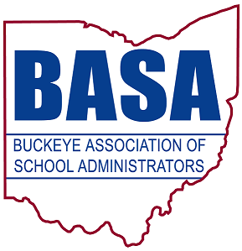


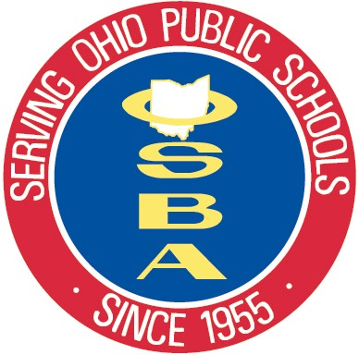

FOR IMMEDIATE RELEASE
Aug. 18, 2014
for more information, contact:

Tom Ash Barbara Shaner
BASA director of governmental relations OASBO associate executive director
(614) 425-3974 cell (614) 325-9562 cell
ash@basa-ohio.org barbara@oasbo-ohio.org

Damon Asbury
OSBA director of legislative services
(614) 832-6663 cell
dasbury@ohioschoolboards.org

Education groups say ‘stay the course’ with Common Core State Standards

COLUMBUS — Three statewide education management organizations today announced opposition to legislation (House Bill 597) that would repeal the Common Core State Standards for mathematics and English language arts. Spokespersons for the Ohio School Boards Association (OSBA), Ohio Association of School Business Officials (OASBO) and Buckeye Association of School Administrators (BASA) spoke at a press conference held at the Ohio Statehouse to reiterate support for “staying the course” with the new standards that school districts have already begun to implement.
BASA Executive Director Kirk Hamilton kicked off the event: “Ohio has a long history of excellence in education and in striving for a strong primary and secondary education system. We can be proud of our progress in making sure students have educational opportunities aimed at preparing them for successful careers and quality higher education options.
“However, Ohio leaders, like those in many other states, recognized that Ohio’s previous learning standards for math and English were not rigorous enough to properly prepare students for the future. They saw the need for a set of education standards that would prepare our students for the new career expectations of the future. The stakes have changed, and so should the rigor of the standards for what our students should know and be able to do.”
Hamilton was followed by two superintendents — Stephen Thompson from Willoughby-Eastlake City Schools and Robert Hill from Firelands Local Schools in Lorain County. They shared support for the Common Core and explained why the standards are good for their students. They also discussed the increased rigor required with the Common Core and described how the standards foster a deeper understanding of subject content as compared to the previous rote learning method of teaching students. The superintendents also shared concerns about the chaos that would ensue should the standards be repealed after one or two years of implementation.

— more —
Education groups say, ‘stay the course’ 2/2/2/2/2

OSBA Executive Director Richard Lewis was next to address attendees: “Education leaders are very passionate about the Common Core standards and the work that has already been done toward implementation. They support ‘staying the course.’ We know the new more rigorous standards are challenging, but we commend districts for their hard work and thoughtful consideration in planning for their implementation. That said, there has been a lot of misunderstanding about who really drives what happens at the local level as the new Common Core standards are implemented.”

Lewis introduced Eric Germann, a school board member at Lincolnview Local Schools and Vantage Career Center in Van Wert County. Germann stressed that local boards are deciding the curriculum used in their districts to prepare students for success. He said he worries that some are confusing the standards with specific curriculum products that are not being used in Ohio, but are contributing to the national debate over Common Core. He stated his support for retaining the standards in Ohio and said he is worried about HB 597 undoing of the work that’s been done to meet the higher standards.

OASBO Executive Director David Varda spoke next: “We know there are those who will criticize the Common Core. Yet the Ohio General Assembly, after hearing some of the concerns from Common Core opponents, has already taken action to allay those concerns. House Bill 487 passed and was signed by the governor in June. The bill specifically directs that local boards of education will have complete control over their district’s curriculum, regardless of which standards the state adopts. It puts aside fears that personally identifiable student information may be used improperly by declaring that Ohio law will not allow the sharing of student data. HB 487 also requires a state-level process for the adoption of any future content standards and a local process for reviewing new curriculum.”

The groups said that a lot of misinformation about the Common Core standards and their origin has been disseminated. They believe this has caused unnecessary anxiety for parents, teachers and even policymakers. However, they believe fears about the standards are unfounded and that efforts to dismantle them will harm students and Ohio’s future.

“Our organizations stand before you as strong proponents of the Common Core standards and continuing the work toward their full implementation,” Lewis said.

_______

In its 59th year, OSBA leads the way to educational excellence by serving Ohio’s public school board members and the diverse districts they represent through superior service, unwavering advocacy and creative solutions.

BASA is a nonprofit professional organization of school system leaders, specifically, superintendents, central office administrators, building-level administrators, higher education administrators and faculty, graduate students and other educational personnel.

OASBO is a not-for-profit educational management organization dedicated to learning, using and sharing the best methods and technology of school business administration.

-30-

