The Bonnie Eddy Educational Supply and Book Grant

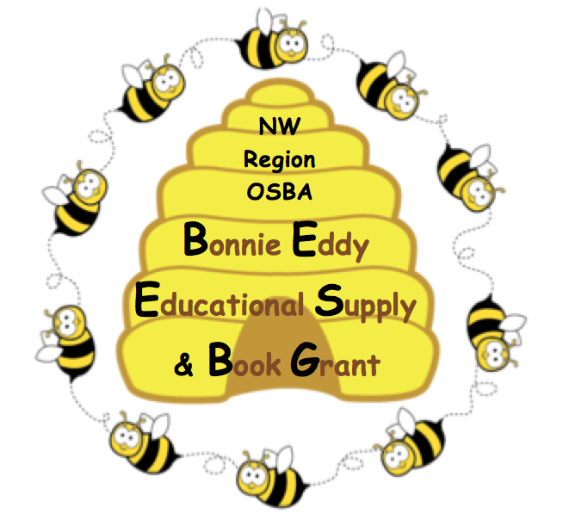
The NW Region Executive Committee of the Ohio School Boards Association is comprised of elected school board members who take pride in providing support to high school seniors demonstrating an interest in the teaching profession. The NW Region OSBA proudly awards a minimum of $2,000 in educational support annually through the Bonnie Eddy Educational Supply and Book Grant (BEES-BG). All seniors in Northwest Ohio whose school district is a member of the Ohio School Boards Association (OSBA) is eligible to apply for one of the $500.00 BEES-BG awards. The recipients of the BEES-BG are invited guests at one of the Northwest Region’s annual Fall Conferences in October, 2021 where special recognition is provided to the recipients, districts, and board members.

SELECTION CRITERIA

- Applicant must be a graduating senior currently enrolled in a school district in the Northwest Region of the Ohio School Boards Association, and have plans to major in teacher education at an accredited college or university in the state of Ohio.
- Applicant must have a grade point average (GPA) in the upper 50% of the class.
- Applicant must demonstrate potential as an educational leader demonstrating professional competence, community involvement, and evidence of good moral character.

SELECTION PROCESS

- Applicants will email their BEES-BG applications for consideration by the last day of January 2021 to jjacksonmay@ohioschoolboards.org
- The NW Region BEES-BG Award Committee will review complete applications and forward selections to the OSBA Scholarship Foundation Board of Directors. Recipients will be contacted in writing by April 15, 2021.
- To receive the award recipients must provide (1) a current course schedule with the students name and institution included, and (2) receipts for purchases of educational supplies or books. The award will be mailed to the student’s home directly after providing the required documents. Funds may be accessed in increments until the total award is expended.

Application must be postmarked by March 23, 2007

Bonne Eddy Educational Supply & Book Grant
BEES - BG
NW Region Ohio School Boards Association

Submission Requirements

A one-page essay describing:

Your future plans and intended major, including what college/university you plan to attend

Why you want to be a teacher

What contributions you would like to make as an educational leader

A minimum of two letters of recommendation, one from an academic teacher and one from a community member (Coaches and counselors are eligible only for additional support unless they have served in an academic capacity).

A listing of your participation in leadership positions, extra-curricular activities, volunteer, and community involvement

A current transcript (can be a copy; does not need to be an original)
Applications must be submitted in a SINGLE PDF with the applicants name on each item and emailed to jjacksonmay@ohioschoolboards.org with BEES-BG in the Subject Line.

FULL contact information IS REQUIRED below. Application may be duplicated as needed.

Name_____________________________________________________________________Phone_______________________________________________________

Address_________________________________________________________________Cell Phone___________________________________________________

City__________________________________________Zip_______________________ E-mail________________________________________________________

School Name_____________________________________________District ______________________________________ County______________________

School Address___________________________________________ City/Town_________________________________________Zip___________________

City _____________________________________________________ Zip _______________________ Phone ___________________________________________

Counselor_______________________________________________ Phone____________________________Email____________________________________

Principal ________________________________________________Phone____________________________Email____________________________________

Grade Point Average_________________________ Class Rank ______________________

Anticipated Area of study: ____________________________________________Anticipated University_____________________________________

I attest that, to the best of my knowledge, the information provided here is true and accurate.

Signature_________________________________________________________________Date__________________________________

E-mail by January 31, 2021 to: Dr. Judy Jackson May
1513 Cobblestone Drive
Bowling Green, OH 43402
Please contact Regional Manager, Dr. Judy Jackson May, with any questions.
jjacksonmay@ohioschoolboards.org
Phone 419.581.9782 419.575.0663
Download the application at www.ohioschoolboards.org/nw-region

