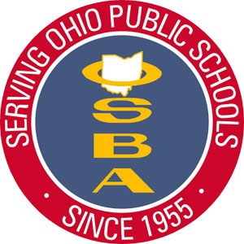
Northwest Region Recognition Programs
Northwest Region Humanitarian Award
recognizes individuals and groups who actively engage in exceptional efforts to improve the welfare of others through their altruistic activities. The NW Region Humanitarian Award honors altruistic efforts both in the schools and community. The purpose is to recognize those demonstrating the ethics of kindness, benevolence, and sympathy in their schools and communities. These individuals have a sincere concern for those around them and go above and beyond the call of duty. This award is peer nominated and is awarded twice per year at the Northwest Region's Spring and Fall Conferences.
While the NW Region OSBA Award Selection Committee will select the winner, all nominees will be recognized.
☐
NW Region Excellence in Community Service Award
rewards school district members and organizations engaged in activities to support and enhance their school and community. The NW Region has extraordinary board members, students, teachers, administrators and community members engaged in noble and selfless community volunteerism. This award honors donated service or activities that are performed by someone or a group of people for the benefit of the public or its institutions demonstrating a deliberate connection between the community and educational development and social goals. This award is peer nominated and is awarded twice per year at the Northwest Region's Spring and Fall Conferences.
Selection Committee will select the winner, all nominees will be recognized.
☐

Who’s Who in the NW Region Excellence Award for Outstanding Leadership
is an award for organizational leadership. This award is special because it recognizes that leadership occurs at ALL levels of the organization…from the playground to the central office. The Who’s Who award is reserved for those who demonstrate exceptional leadership for the betterment of the district. The nominees for this award are generated by those who work with an around them and is awarded twice per year at the Northwest Region's Spring and Fall Conferences. While the NW Region OSBA Award Selection Committee will select the winner, all nominees will be recognized.
☐

Nominee Information
(Please complete ALL applicable information)
Name_______________________________________________________
Grade Level / Title / Position (if applicable) __________________________
___________________________________________________________
Address ____________________________________________________
E-Mail______________________________Phone____________________
School / District ______________________________________________
City __________________________ County________________________
Group Advisor /Director_________________________________________
Advisor E-mail_________________________Phone___________________

(Please check one box for the selected award above. Please complete a separate nomination/submission for each nomination)
Nomination Form
Please (✔) the categories that most closely describe(s) your nominee (s) and complete the information below.
_____ School Volunteer Individual
_____ School Volunteer Group
_____ District Level Administrator / Leader
_____ Building Level Administrator / Leader
_____ School Board Member / School Board
_____ Parent Group
_____ Community Organization / Business
_____ Program or Innovation

_____ Elementary School Level Individual
_____ Elementary School Level Group
_____ Middle School Level Individual
_____ Middle School Level Group
_____ High School Level Individual
_____ High School Level Group
_____ Faculty / Staff
_____ Classified Staff

Affiliated District Superintendent_____________________________________________Phone ____________________________E-mail______________________________
Affiliated Principal ________________________________________________________Phone____________________________E-mail______________________________
Full name of Nominator_____________________________________ Position/Title______________________________________ Contact Phone________________________
Complete Address ________________________________________________ E-mail #1 __________________________________E-mail #2___________________________
In a WORD DOC please describe the nominee’s activities in detail providing as much information as possible to assist the Award Selection Committee in the decision-making process. Email this form and your activity description to judyjac@bgsu.edu or Dr. Judy Jackson May, OSBA Regional Manager, 1513 Cobblestone Drive, Bowling Green, OH 43402 Pho
419.575.0663 Please e-mail this form and all additional documents in a WORD Doc by January 31, 2020 Thank You!!
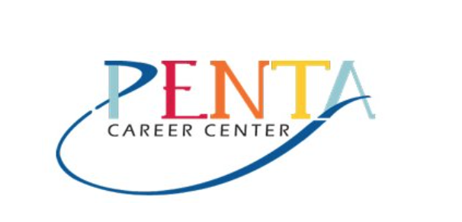
Thursday, March 12, 2020 Penta Career Center ~ 9301 Buck Road, Perrysburg, Ohio 43551

I am willing to assist in recognizing the nominee(s) at the Conference YES NO

